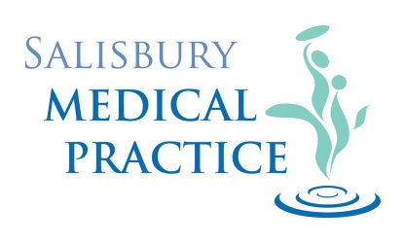

Protocol for spouses of military personnel serving abroad

Serving military personnel within the UK are to use Military medical facilities and are not to be registered with any other civilian Practice.
Families can only use these Military services if posted abroad with their spouse.
Families of serving personnel are not entitled to stay registered with their civilian Practice whilst abroad with their spouse. They should register themselves and any children at the following address:
Queen Elizabeth Memorial Health Centre (QEMH)
St Michaels Avenue
Tidworth
Wiltshire
SP9 7EA

01980 650640

This address is due to change to a Practice in Litchfield in the near future but is correct as at 01 October 2018. Further details will be available with QEMH as soon as the new details are confirmed.

The above Practice will register patients of personnel serving abroad and should the event arise where the Patient requires hospital treatment in the UK it will be arranged by their Medical Centre in the country in which they are residing and QEMH.

