| Musculoskeletal physiotherapy outpatient services | | | | | | | | |
| --- | --- | --- | --- | --- | --- | --- | --- | --- |
| **PART ONE: Screening form for Self-Referral** | | | | | | | | |
| PLEASE COMPLETE THIS CHECKLIST TO SEE IF YOU ARE SUITABLE FOR SELF REFERRAL TO PHYSIOTHERAPY | | | | | | | | |
| 1. Are you under 16 years old? | | | | | YES 🞎 NO 🞎 | | | |
| 2. Are you filling in this form on behalf of someone else? | | | | | YES 🞎 NO 🞎 | | | |
| 3. Have you attended Physiotherapy for the same condition in the last 6 months? | | | | | YES 🞎 NO 🞎 | | | |
| 4. Has your general health changed recently in any way that you haven’t discussed with your GP? | | | | | YES 🞎 NO 🞎 | | | |
| 5. Have you had a significant accident recently, for which you have not sought medical advice? | | | | | YES 🞎 NO 🞎 | | | |
| 6. Is this problem to do with; | | | | |  | | | |
| * Your breathing/chest | | | | | YES 🞎 NO 🞎 | | | |
| * A neurological problem e.g. Stroke or multiple sclerosis | | | | | YES 🞎 NO 🞎 | | | |
| * Incontinence | | | | | YES 🞎 NO 🞎 | | | |
| 7. If you have back pain: Since the pain came on have you developed any of the following symptoms; | | | | |  | | | |
| * Problems passing urine | | | | | YES 🞎 NO 🞎 | | | |
| * Problems controlling bowel movements | | | | | YES 🞎 NO 🞎 | | | |
| * Pins and needles or numbness between your legs or around your back passage | | | | | YES 🞎 NO 🞎 | | | |
| **IF YOU HAVE ANSWERED ‘YES’ TO ANY OF THE QUESTIONS ABOVE, YOU ARE NOT SUITABLE FOR SELF-REFERRAL TO PHYSIOTHERAPY.** Please contact your GP Practice to find out who the best person is to speak to, or see, regarding your problem/condition. | | | | | | | | |
| If you have answered ‘no’ to all the questions above, then please answer the questions below and proceed to PART TWO | | | | | | | | |
| **Consent to Data Sharing**  Do you consent to information recorded by us being shared with other health  Care professionals? YES 🞎 NO 🞎  Do you consent to this organisation viewing data relating to your care held  on other GP systems? (GP, Out of hours etc.) YES 🞎 NO 🞎 | | | | | | | | |
| **Name: …………………………………… NHS no: ………………………………….****Signed:…………………………………… Date:………………………………………** P.T.O. | | | | | | | |
| **MUSCULOSKELETAL PHYSIOTHERAPY OUTPATIENT SERVICES** | | | | | | | |
| **PART TWO: Patient details for Self-Referral – PLEASE COMPLETE EVERY SECTION** | | | | | | | | | |
| **INCOMPLETE OR ILLEGIBLE FORMS WILL NOT BE ACCEPTED** | | | | | | | |
| Date |  | NHS Number (if known) |  | | | | |
| Surname |  | Forename(s) |  | | | | |
| Previous Surname |  | Title (eg Mr, Mrs) |  | | | Sex (M/F) |  |
| Date of Birth |  | Daytime Tel No |  | | | | |
| Address |  | Mobile No |  | | | | |
| Can we leave a message: YES 🞎 NO 🞎 | | | | | |
| GP Practice |  | | | | |
| Post Code |  |
| Please give us a brief description of your problems or symptoms: | | | | | | | |
| How long have you had these symptoms: | | | | | | | |
| Have you had any other interventions or treatments for this problem? (Include dates) | | | | | | | |
| Please complete the following questions: | | | | | | | |
| Did your GP suggest you complete this form? | | | | YES 🞎 NO 🞎 | | | |
| Is your problem worsening? | | | | YES 🞎 NO 🞎 | | | |
| Are you able to continue your normal activities? | | | | YES 🞎 NO 🞎 | | | |
| Is this problem preventing you from working? | | | | YES 🞎 NO 🞎 | | | |
| When you have completed PART TWO please send to us by:  **Post**: Physiotherapy Department, Salisbury District Hospital, Salisbury, Wilts. SP2 8BJ  **Email**: [whc.mskphysiobookingcentre@nhs.net](mailto:whc.mskphysiobookingcentre@nhs.net)  **By hand**: to your GP Practice or local physiotherapy department who will forward it onto the Physiotherapy Central Booking Department on your behalf.  P.T.O. | | | | | | | |

| Musculoskeletal physiotherapy outpatient services | |
| --- | --- |
| **PART THREE:**  **DO NOT COMPLETE UNLESS YOU HAVE LOW BACK PAIN AND/OR SCIATICA**  **Screening form for self-referral for low back pain and sciatica** | |
| PLEASE COMPLETE BOTH SIDES OF THIS FORM IF YOU ARE SELF-REFERRING TO PHYSIOTHERAPY FOR **LOW BACK PAIN OR SCIATICA** | |
|  | |
| Please indicate which service you think you would be most interested in.  Our leaflets give more for information on our services  I would be interested in: |  |
| Back Pain Management Classes |  |
| * Activate Your Back (one-off class) | YES 🞎 NO 🞎 |
| * Back class (six week course) | YES 🞎 NO 🞎 |
| One-to-One Physiotherapy Appointment | YES 🞎 NO 🞎 |
| Telephone Appointment | YES 🞎 NO 🞎 |

## **Name: …………………………………… NHS no: ………………………………….**

## 

## **Date of birth: …………………………… Date:……………………**

P.T.O.

| Musculoskeletal physiotherapy outpatient services |
| --- |
| **PART FOUR: Screening form for self-referral for low back pain and sciatica** |

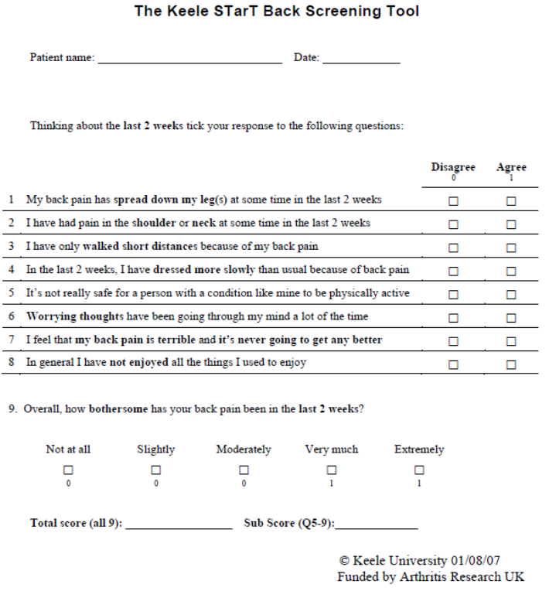

P.T.O.